Test Case: tc001_SPX_Dev5_Crear_Nueva_Linea_Requisicion_Spot_Tipo_Cobro_CC
Step 1 - Enter username and password and click to button Enter : Credentials Entered
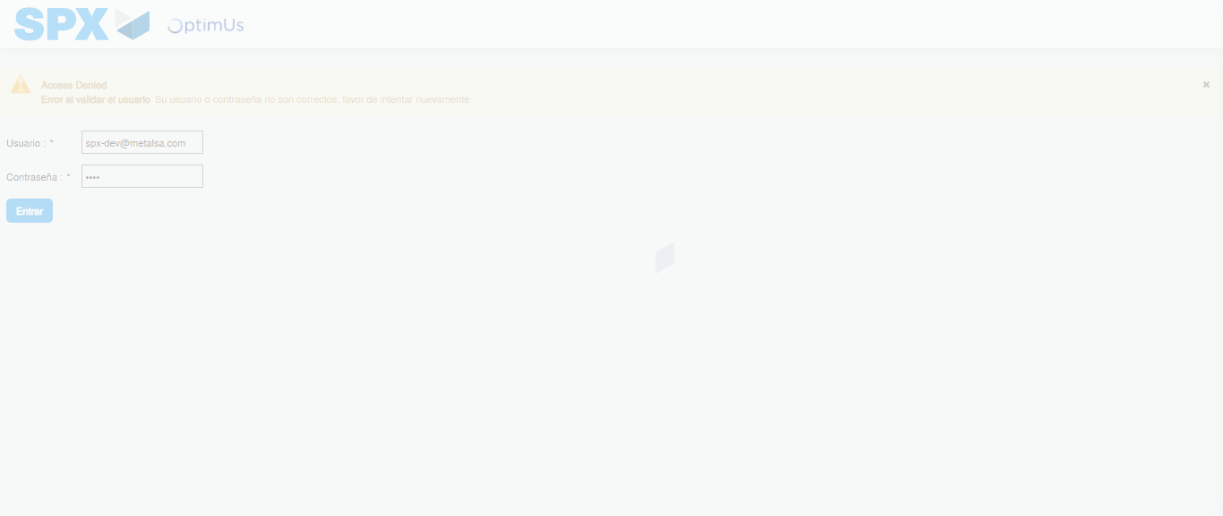Image file-name: QC_Testing-tc001_SPX_Dev5_Crear_Nueva_Linea_Requisicion_Spot_Tipo_Cobro_CC-1790176421280

Step 2 - Select to UEN and Access to Spot Buy Requisitions : UEN Correctly selected and Correct access
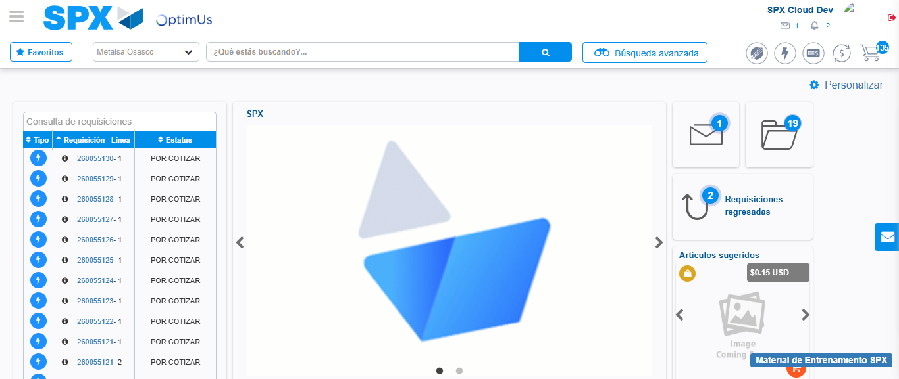Image file-name: QC_Testing-tc001_SPX_Dev5_Crear_Nueva_Linea_Requisicion_Spot_Tipo_Cobro_CC-1790176444856

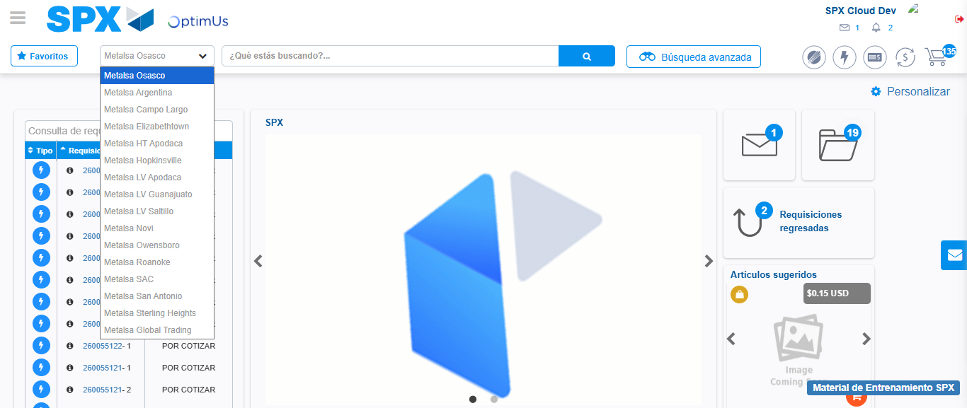Image file-name: QC_Testing-tc001_SPX_Dev5_Crear_Nueva_Linea_Requisicion_Spot_Tipo_Cobro_CC-1790176445354

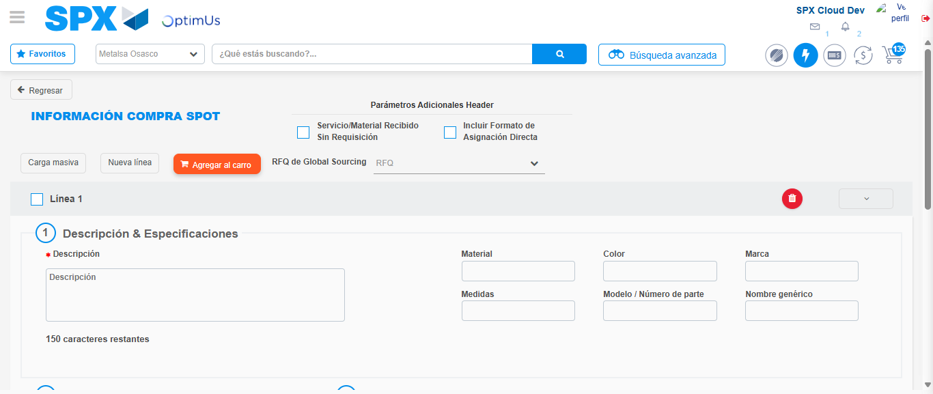Image file-name: QC_Testing-tc001_SPX_Dev5_Crear_Nueva_Linea_Requisicion_Spot_Tipo_Cobro_CC-1790176449544

Step 3 - Data Capture Spot Buy Requisition: Data captured correctly
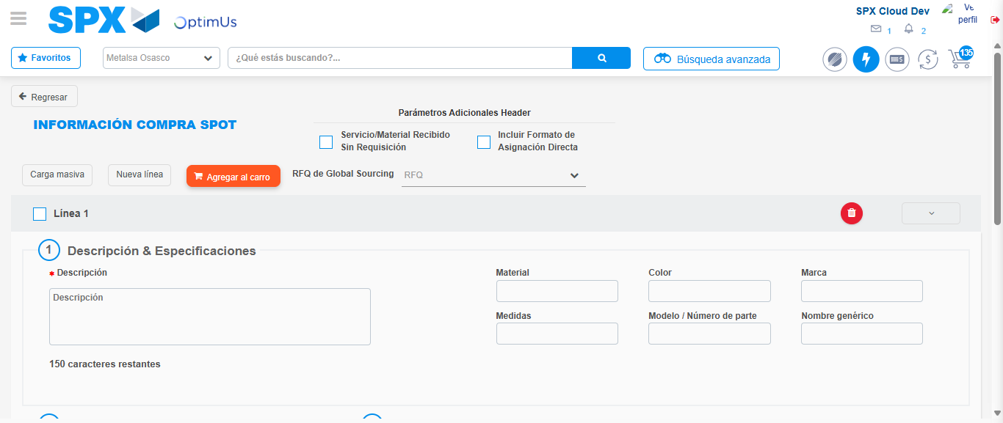Image file-name: QC_Testing-tc001_SPX_Dev5_Crear_Nueva_Linea_Requisicion_Spot_Tipo_Cobro_CC-1790176449796

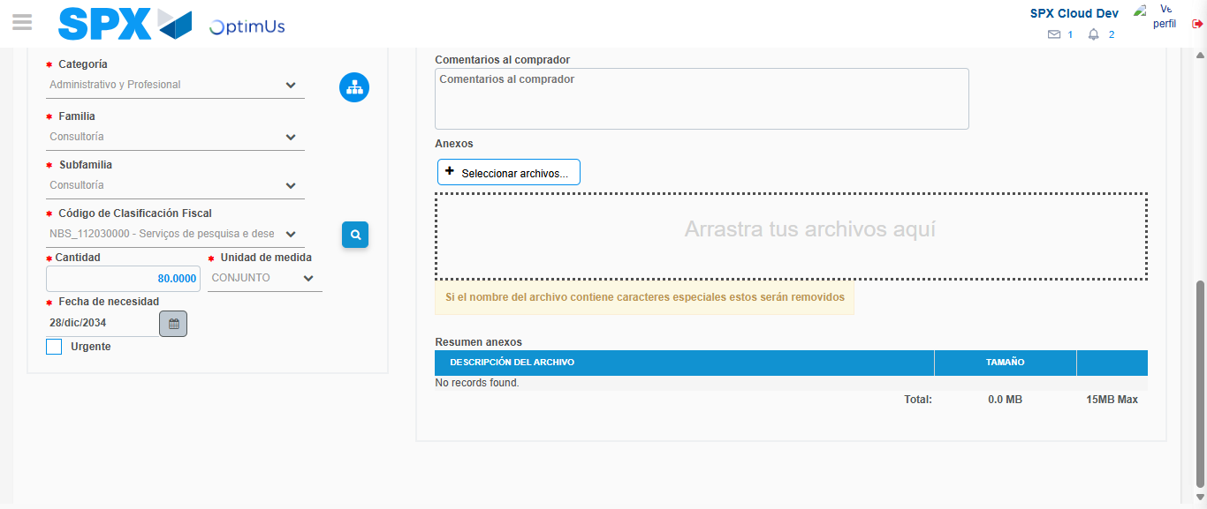Image file-name: QC_Testing-tc001_SPX_Dev5_Crear_Nueva_Linea_Requisicion_Spot_Tipo_Cobro_CC-1790176465366

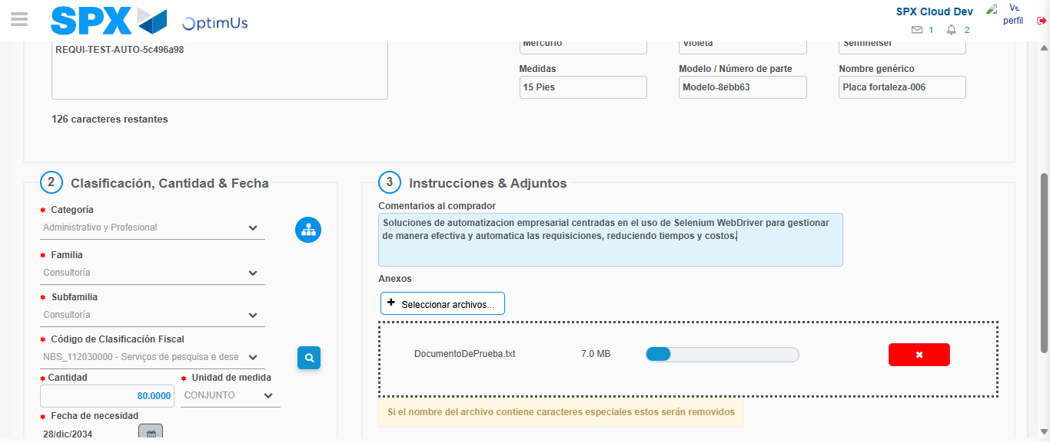Image file-name: QC_Testing-tc001_SPX_Dev5_Crear_Nueva_Linea_Requisicion_Spot_Tipo_Cobro_CC-1790176466086

Step 4 - Add new line and data capture second line: Line add correctly
Image file-name: QC_Testing-tc001_SPX_Dev5_Crear_Nueva_Linea_Requisicion_Spot_Tipo_Cobro_CC-1790176449796

Image file-name: QC_Testing-tc001_SPX_Dev5_Crear_Nueva_Linea_Requisicion_Spot_Tipo_Cobro_CC-1790176465366

Image file-name: QC_Testing-tc001_SPX_Dev5_Crear_Nueva_Linea_Requisicion_Spot_Tipo_Cobro_CC-1790176466086

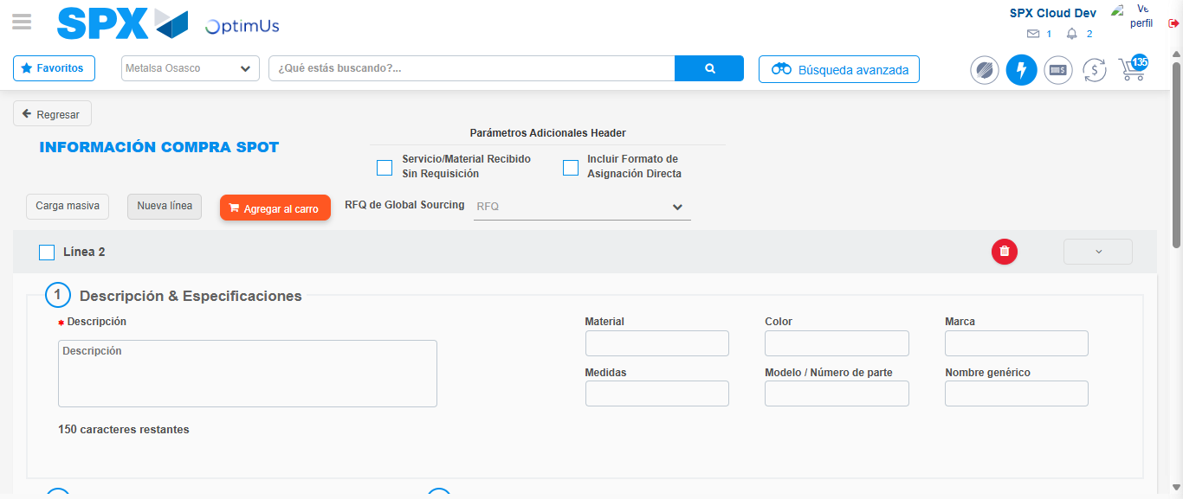Image file-name: QC_Testing-tc001_SPX_Dev5_Crear_Nueva_Linea_Requisicion_Spot_Tipo_Cobro_CC-1790176468315

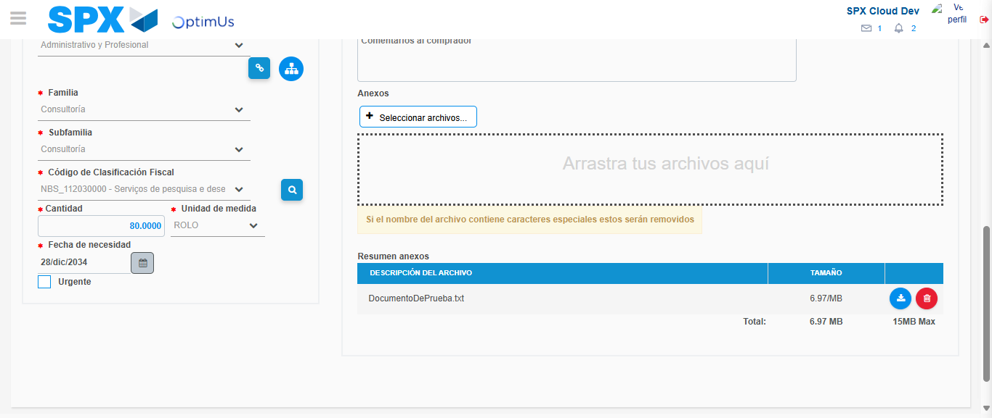Image file-name: QC_Testing-tc001_SPX_Dev5_Crear_Nueva_Linea_Requisicion_Spot_Tipo_Cobro_CC-1790176484776

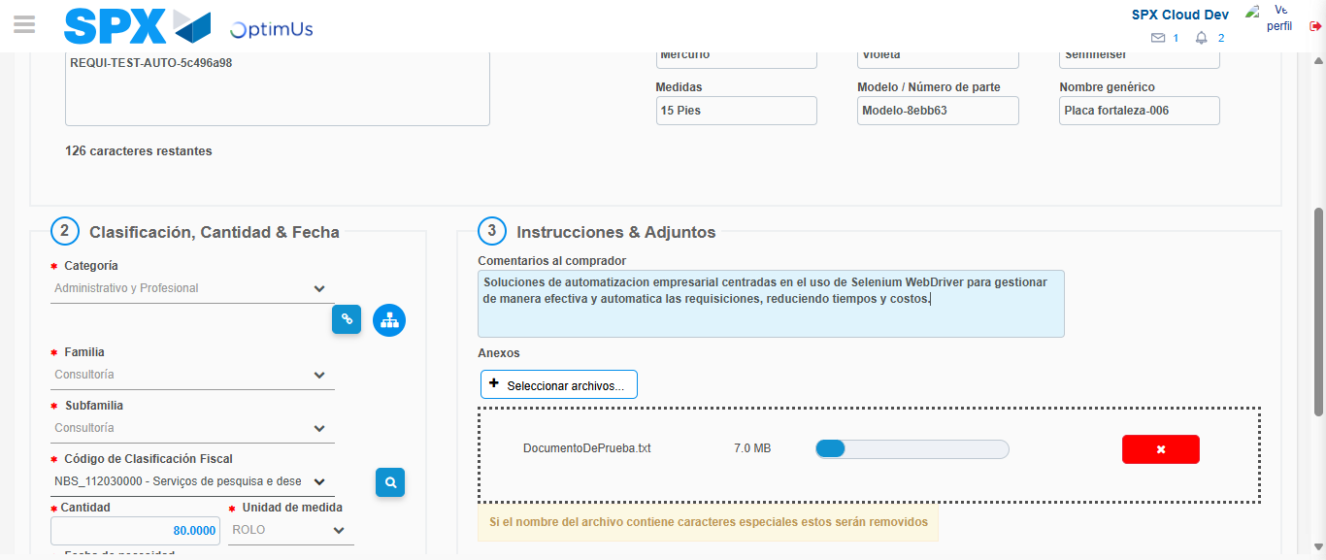Image file-name: QC_Testing-tc001_SPX_Dev5_Crear_Nueva_Linea_Requisicion_Spot_Tipo_Cobro_CC-1790176485520

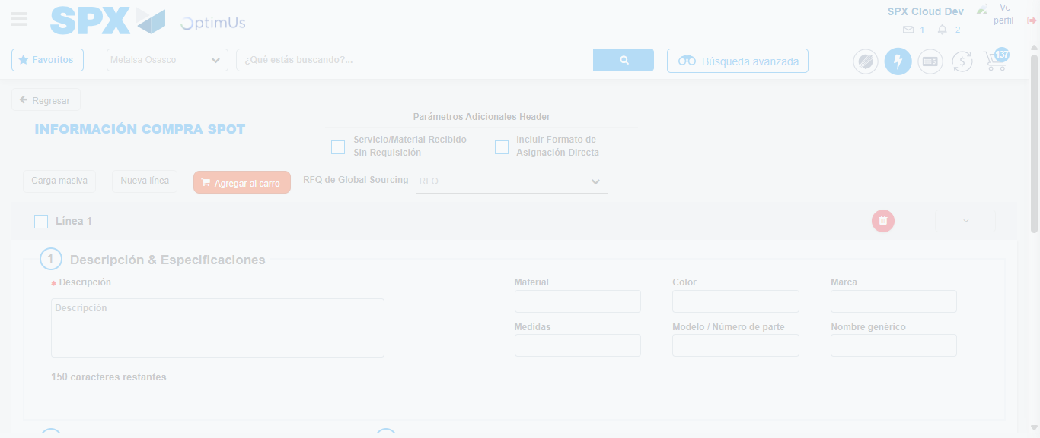Image file-name: QC_Testing-tc001_SPX_Dev5_Crear_Nueva_Linea_Requisicion_Spot_Tipo_Cobro_CC-1790176492903

Step 8 - Return to Main Page SPX : Return to Main Page SPX
Image file-name: QC_Testing-tc001_SPX_Dev5_Crear_Nueva_Linea_Requisicion_Spot_Tipo_Cobro_CC-1790176444856

Image file-name: QC_Testing-tc001_SPX_Dev5_Crear_Nueva_Linea_Requisicion_Spot_Tipo_Cobro_CC-1790176445354

Image file-name: QC_Testing-tc001_SPX_Dev5_Crear_Nueva_Linea_Requisicion_Spot_Tipo_Cobro_CC-1790176449544

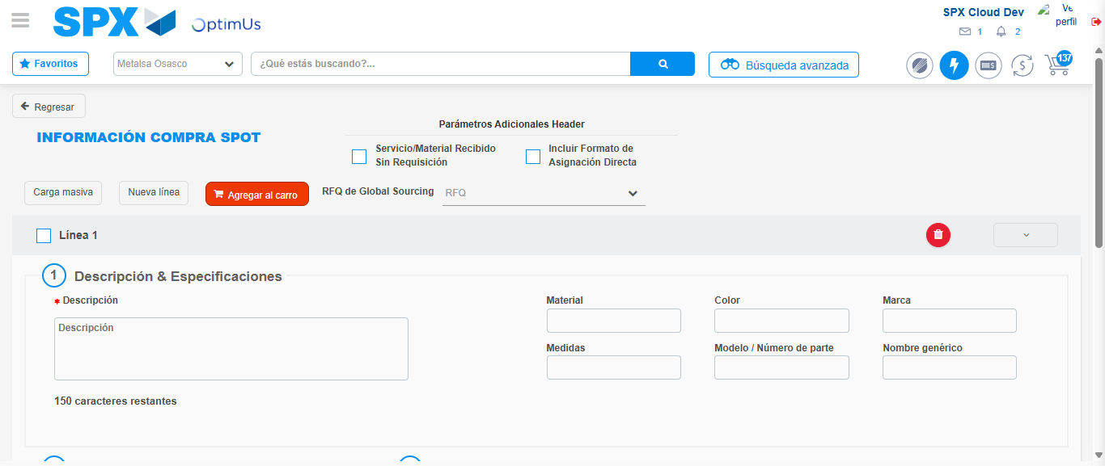Image file-name: QC_Testing-tc001_SPX_Dev5_Crear_Nueva_Linea_Requisicion_Spot_Tipo_Cobro_CC-1790176495108

Image file-name: QC_Testing-tc001_SPX_Dev5_Crear_Nueva_Linea_Requisicion_Spot_Tipo_Cobro_CC-1790176495276

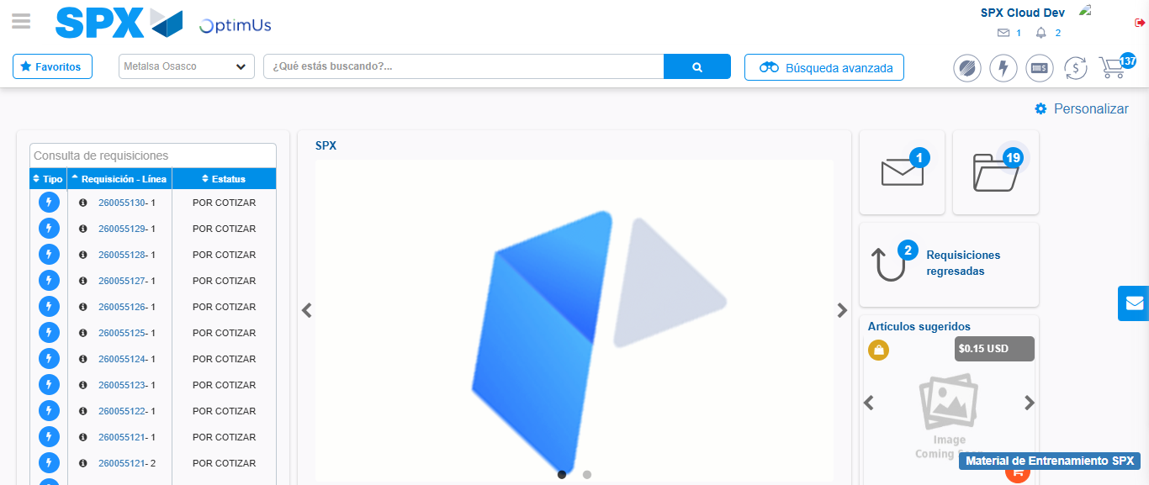Image file-name: QC_Testing-tc001_SPX_Dev5_Crear_Nueva_Linea_Requisicion_Spot_Tipo_Cobro_CC-1790176516492

Step 9 - Log Out : Log Out SPX
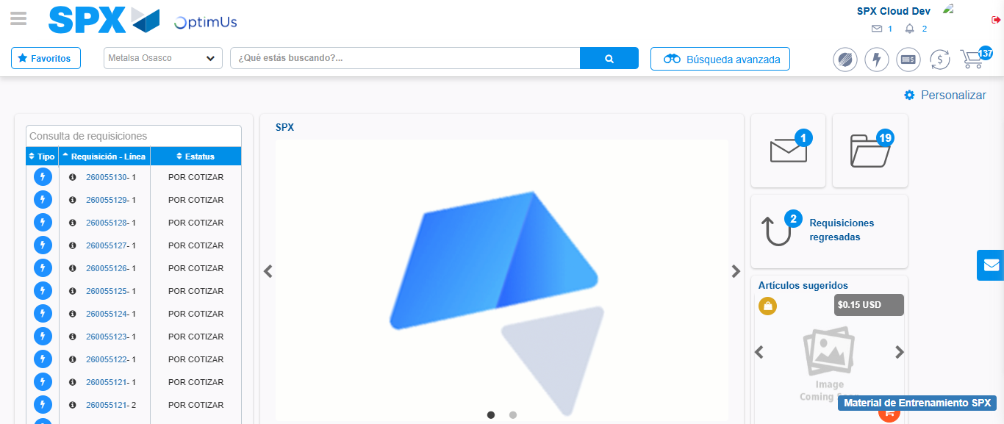Image file-name: QC_Testing-tc001_SPX_Dev5_Crear_Nueva_Linea_Requisicion_Spot_Tipo_Cobro_CC-1790176516799

